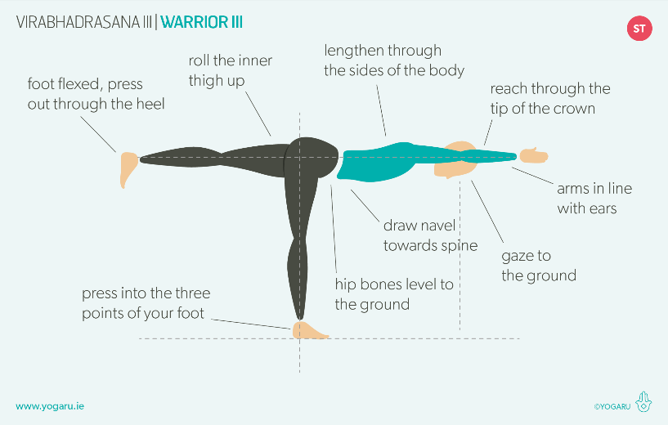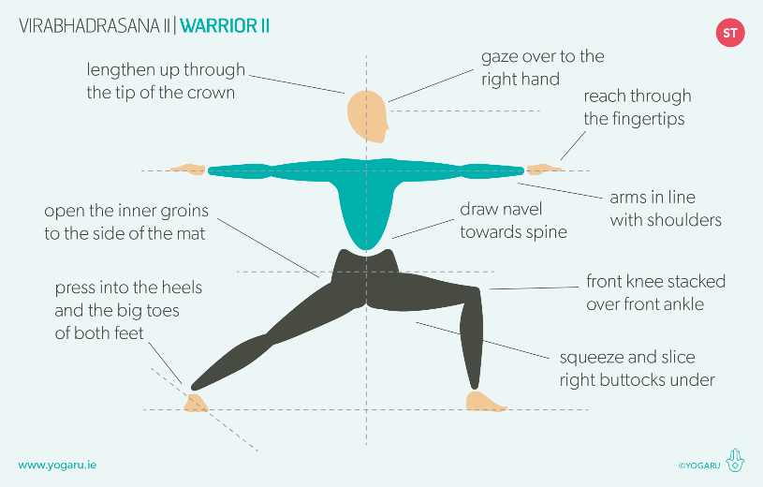Warrior pose 1 2 3 & Reverse

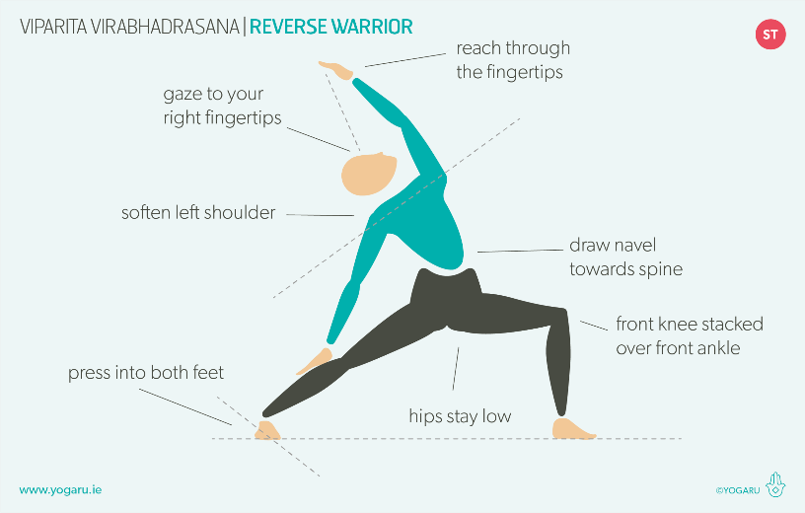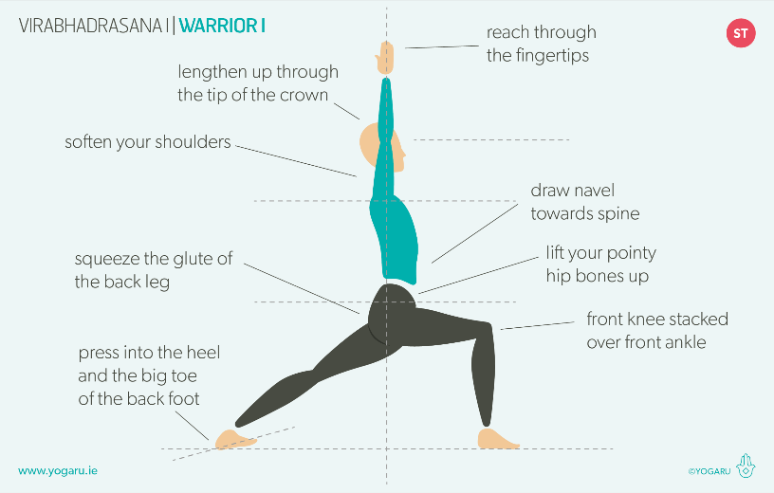

Purging exercise & tap meridians

Raise heel, raise toe (rocking)

Arm Swings

Crossover hands and reach up

Horse stance cross arms squat

Dragon style twist

Stand against a wall stretch up